Executive Branch

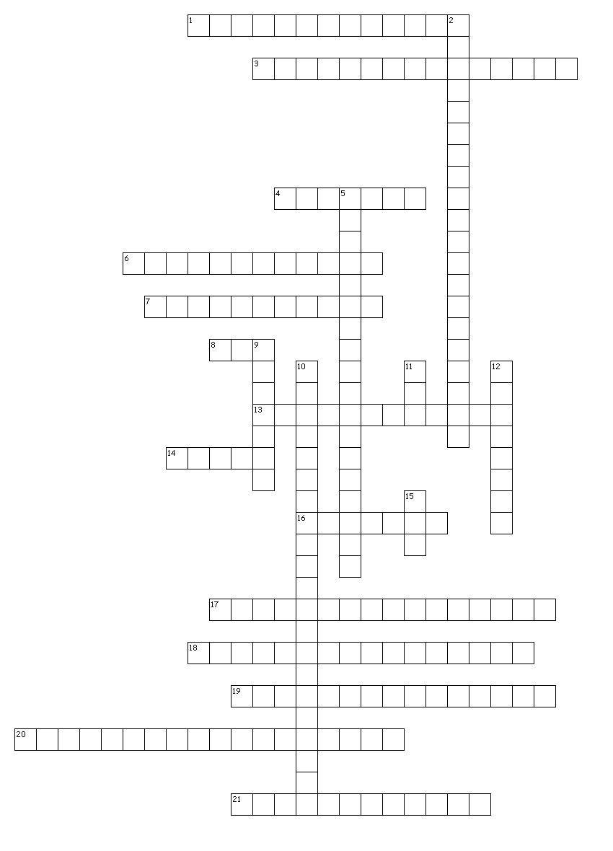
DO NOT PRINT THIS! JUST NUMBER A DOCUMENT FROM 1-21 WRITE THE CORRECT TERM FOR EACH NUMBER. Submit the document onto turnitin.com. Chapters 8-10 in the textbook will assist you in completing the crossword puzzle.

Across
1. This role makes the President the main architect of American Foreign Policy
3. This address is given by the president to Congress
4. This department was once called the Department of War
6. This created the civil service system
7. Civil servants who work for the federal government are known as
8. This group advises the president on military and foreign policy
13. The secretaries of state, defense, treasury, and the attorney general are known as the
14. This department is responsible for the overall foreign policy of the United States
16. Following the vice president, the next in succession for the presidency
17. This role gives the President control of the nation’s armed forces
18. This system is often called a winner-take-all system
19. This role makes the President the main architect of public policies
20. This role makes the President the director of the United States government
21. This role means the President is the ceremonial head of the government of the United States

Down
2. This deals with presidential succession
5. The right of the president to refuse to testify before Congress or a court is called
9. This group is chosen by the president for their experience in selected areas
10. The Constitution gave Congress this power over the president's veto
11. This is the largest agency of the Executive Office of the President
12. This item limits federal employees’ involvement in election campaigns
15. A president cannot exceed this number of years in office

