Legislative Branch

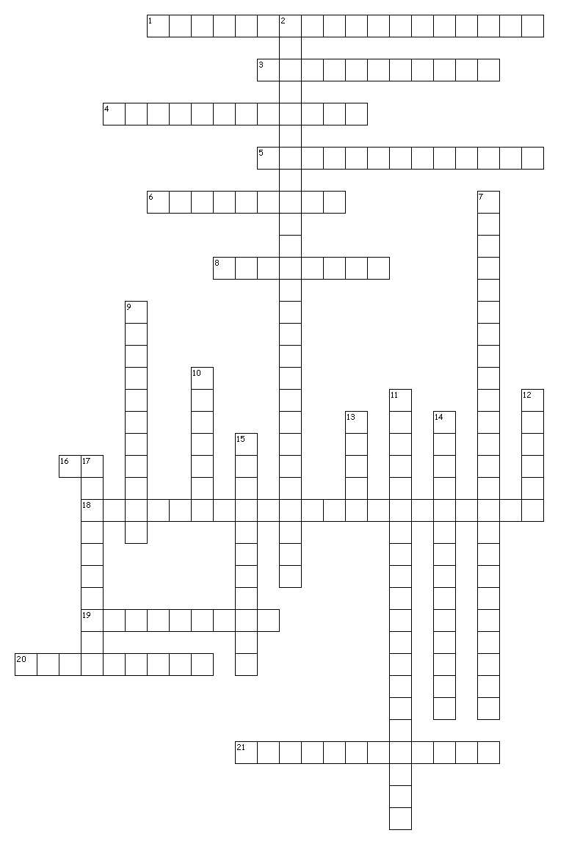

DO NOT PRINT THIS! JUST NUMBER A DOCUMENT FROM 1-21 WRITE THE CORRECT TERM FOR EACH NUMBER. Submit the document onto turnitin.com. Chapter 5-7 in the textbook will assist you in completing the crossword puzzle.

Across
1. Congress may not suspend this court order that releases a person accused of a crime
3. These bills deal with general matters and apply to the entire nation
4. People in districts represented in Congress are called:
5. The standing committees of each house are controlled by:
6. representatives of interest groups
8. Some historians believe that the checks and balances system causes__________
16. president of the Senate
18. Matters requiring the action of both the House and Senate, but on which a law is not needed
19. In Article I, Section 8 of the Constitution, these powers of Congress are described:
20. tend to favor social-welfare programs
21. This group specializes in a subcategory of its standing committee's responsibility

Down
2. Almost all the important work on tax laws occurs in the:
7. What implies that Congress has powers beyond those expressed in the first 17 clauses of Article I, Section 8?
9. tend to favor business
10. presiding officer of the House
11. This power allows Congress to check on how the executive branch is administering the law
12. closed meeting
13. assist the floor leader
14. These committees act as study groups for the House and Senate
15. This is a formal accusation of misconduct against a public official
17. This action could allow the president to kill a bill during the last 10 days Congress is in session by refusing to act on it

