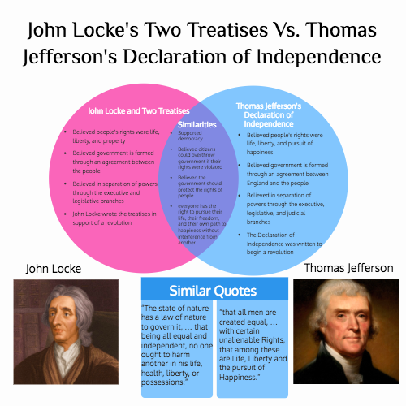

In what ways does the Declaration of Independence express the ideas of John Locke? Write a reflective paragraph which must be a minimum of 2/3 of a page typed double-spaced, Arial, 12 font.

